**PROGRAM 9 : QUICKSORT**

CODE:

#include <stdio.h>

#include <stdlib.h>

#include <time.h>

void quicksort(int [], int, int);

int main()

{

clock_t start,end;

double time;

int i, n, a[100000];

printf("Enter the size of the array:\n");

scanf("%d", &n);

printf("Enter the elements in the array:\n");

for (i = 0; i < n; i++)

{

a[i] = rand()%100;

printf("%d ",a[i]);

}

start = clock();

quicksort(a,0,n-1);

end = clock();

time = ((double)(end - start))/CLOCKS_PER_SEC;

printf("\nTime taken : %lf\n",time);

printf("\nThe sorted list in ascending order is\n");

for (i = 0; i < n; i++)

{

printf("%d ",a[i]);

}

return 0;

}

void quicksort(int a[100000],int first,int last){

int i, j, pivot, temp;

if(first<last){

pivot=first;

i=first;

j=last;

while(i<j){

while(a[i]<=a[pivot]&&i<last)

i++;

while(a[j]>a[pivot])

j--;

if(i<j){

temp=a[i];

a[i]=a[j];

a[j]=temp;

}

}

temp=a[pivot];

a[pivot]=a[j];

a[j]=temp;

quicksort(a,first,j-1);

quicksort(a,j+1,last);

}

}

OUTPUT:

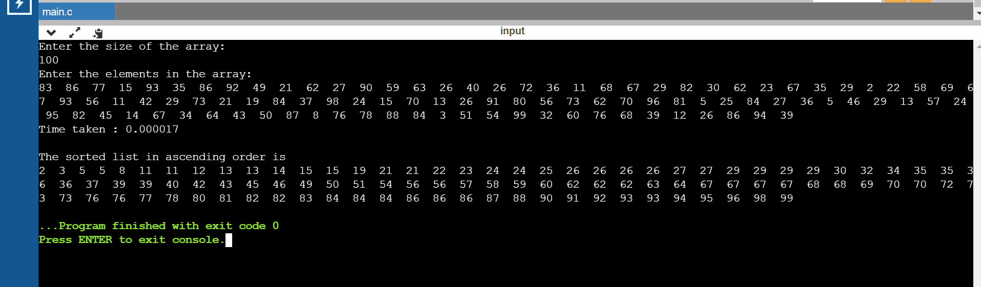

|  |  |
| --- | --- |
| N | Time Taken |
| 50 | 0.000008 |
| 100 | 0.000017 |
| 200 | 0.000026 |
| 500 | 0.000083 |
| 1000 | 0.000122 |
| 5000 | 0.000858 |
| 10000 | 0.002929 |
| 15000 | 0.005951 |
| 20000 | 0.009067 |
| 25000 | 0.012314 |